APPENDIX FOUR

CAMPUS MAP

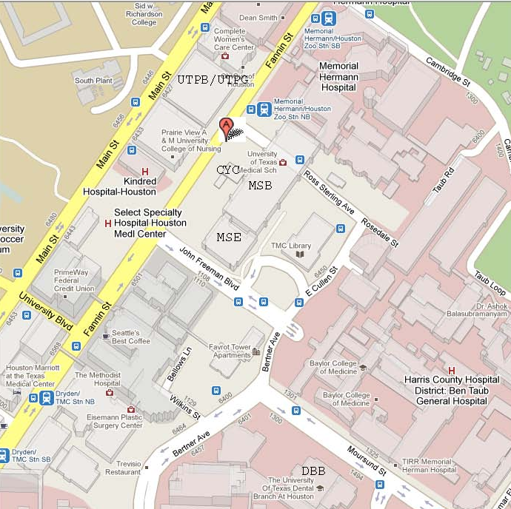

Facility locations in this image:
MSB – Medical School Building
MSE – Medical School Expansion Building
CYC – Cyclotrone Building
UTPB – University Professional Building
UTPG – University Professional Garage

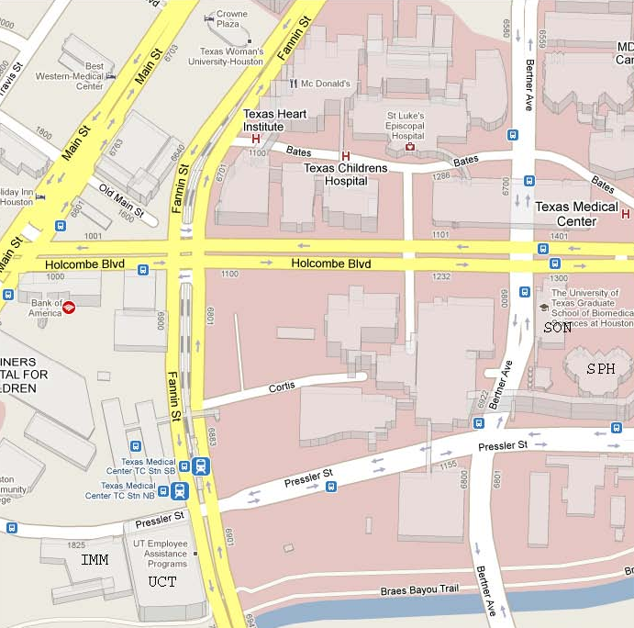

Facility locations in this image:
SON – School of Nursing
SPH – School of Public Health
UCT – University Center Tower
IMM – Institute of Molecular Imaging

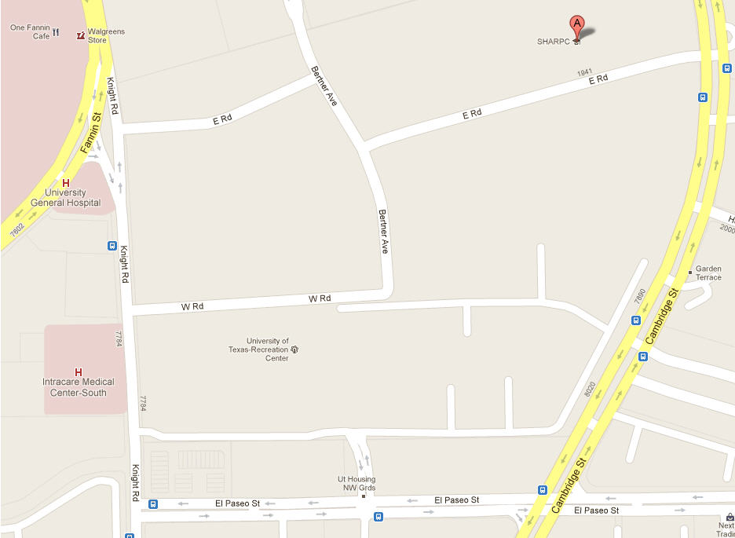
STUDENT / FACULTY HOUSING
AUX / REC
SOD
BBS

Facility locations in this image:
BBS – Behavioral & Biomedical Sciences
SOD – School of Dentistry
AUX / REC – Auxiliary Enterprises & Recreation Center
SFA – Student / Faculty Housing Complex

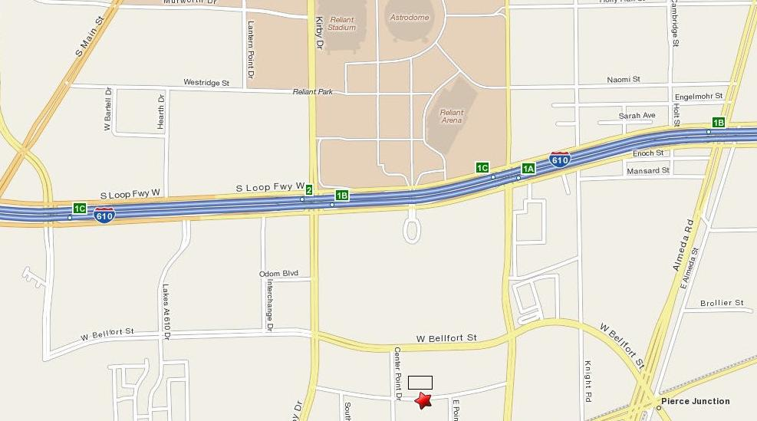

Facility locations in this image:
OCB – Operations Center Building

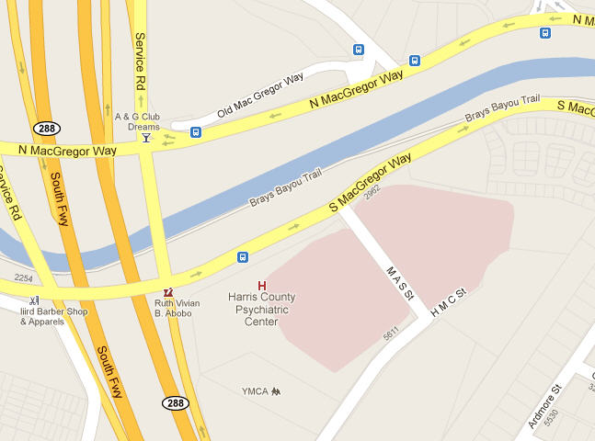
HCPC
Facility locations in this image:
HCPC – Harris County Psychiatric Center

